|  |
| --- |
| **RM 194 Decision Analysis-MSBA** |
| **Fall 2019**  **Final Exam** |

**You are allowed to have one page of notes. There are 2 problems with multiple parts. Points are stated at (or near) the beginning of each part. The maximum point total is 100. Please show all of your work on the exam sheet in the space provided; any work not included on the exam sheet will not be graded.**

**Name: ___________**Matthew Zlotnik**_____________________**

**Good luck!**

**Problem 1 (50 points)**

The harvest season for Riesling grapes was fast approaching in Napa Valley, and Bill Jackson had to decide about his harvesting plan at Hillview Winery. According to the latest weather report, a storm was approaching the winery, and he could decide to harvest the grapes immediately or leave them on the vine. A storm just before the harvest is usually detrimental and may ruin the crop. A warm, light rain, however, will sometimes cause a beneficial mold *botrytis cinerea* to form on the grape skins. The result is a luscious sweet wine highly valued by connoisseurs.

The winery typically bottled about 1,000 cases of Riesling each year. A case contains 12 bottles of wine.

Wine is produced and aged in barrels for one or more years until it is ready for bottling. The winemaker can influence the style of wine produced by selecting the type of wooden barrel used for aging and by other decisions. Usually, as the grapes ripen, the sugar levels increase and the acidity levels decrease. The winemaker tries to harvest the grapes when they have achieved the proper balance of sugar and acidity for the type of wine sought. Several types of Riesling can be produced depending on the sugar level. The wine will either be considered “dry” or “sweet” as a result. A third and rare wine occurs when the grapes are attacked by the *botrytis* mold.

From the weather reports, Mr. Jackson concluded that there was a fifty-fifty chance that the rain storm would hit Napa Valley. If it did hit, he estimated that there was a forty percent chance that it would lead to the development of the *botrytis* mold. However, if the botrytis did not form then the rainwater would swell the berries and the result would be a thin wine that he would sell in bulk for only about $1.00 per bottle wholesale in order to avoid damaging the winery’s reputation, about $1.85 less than Jackson could obtain by harvesting the grapes immediately and eliminating the risks.

If Jackson decided not to harvest the grapes immediately and the storm did not hit, he would leave the grapes to ripen more fully. With luck regarding the weather, they would ripen to a high sugar level that would sell for $3.50 per bottle wholesale. Even with less favorable weather, the sugar levels would probably raise to a level that would justify a wholesale price of $3.00. Jackson thought these outcomes were equally likely. However, there would be a worst case with low acidity that would only justify a price of $2.50. He thought this latter event only had a .2 probability.

The wholesale price for a *botrytised* Riesling would be about $8.00 per bottle. Unfortunately, the process that produced this special wine also resulted in a 30% reduction in the total volume of wine produced. Although fewer bottles would be produced the costs of making and bottling the wine would be about the same as for the other wines and were small in any case relative to the wholesale price.

a. (15 points) Paste the decision tree below to evaluate Mr. Jackson’s alternatives.

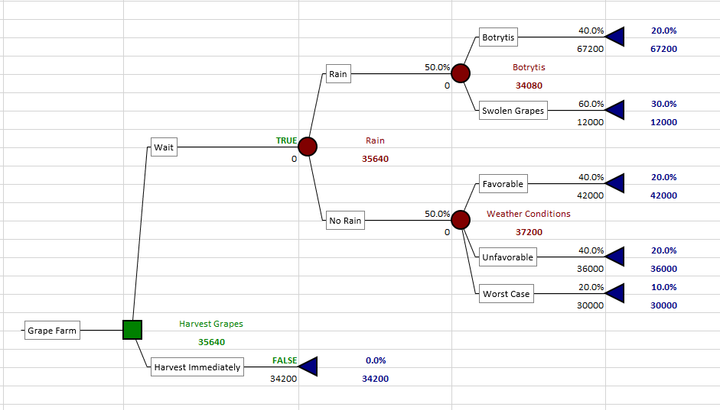

b. (5 points) Recall that the process used to produce the *botrytised* Riesling resulted in a 30% reduction in the total volume of wine produced. Perform a sensitivity analysis and determine what the reduction in the total volume of wine produced would have to be in order to change the decision recommended by the tree. Show the sensitivity analysis graph below as well as your written answer.

*The sensitivity analysis graphs below show that at around 38% reduction in volume, Mr. Jackson should no longer wait to harvest the grapes, as the reduction in total volume from the Botrytis makes the decision to wait less profitable than the decision to harvest immediately.*

c. (5 points) Suppose Mr. Jackson contacts the Department of Viticulture & Enology (wine making) at the University of California at Davis and discovers that they have developed a compound that can be sprayed on Riesling grapes before a rain occurs, and that it will ensure (100 percent) that the *botrytis* mold will form if it does rain. What is the most that he should be willing to pay for acquiring and spraying this compound to control this risk? Note that it is not necessary to show the tree.

*If this compound can create a 100% chance that Botrytis will form given rain, then this compound would increase the expected value of the decision to wait to harvest from $35,640 (above) to $52,200, thus Mr. Jackson should be willing to pay at most $16,560 to acquire and spray the solution onto his entire crop.*

d. (5 points) As an alternative, Mr. Jackson could consult a private meteorologist regarding the chances of rain at his vineyard, as opposed to a forecast for the Napa Valley area. This meteorologist had been helpful in the past, but her forecast was not always perfect. According to Mr. Jackson’s records, she “predicted rain” 90 percent of the time when it actually did rain. However, she also “predicted rain” 20 percent of the time when it did not rain. Note that this analysis will require some probability calculations. Show those calculations below doing the analysis by hand or with the use of the PrecisionTree software.

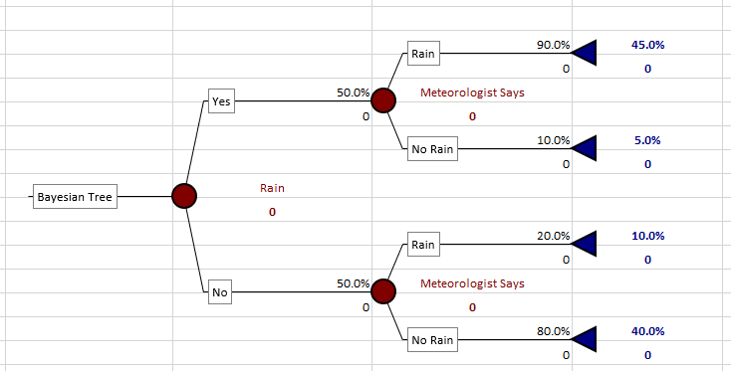

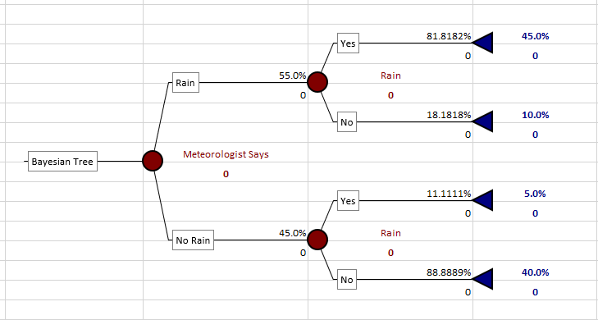

e. (10 points) Now create and show below the part of the tree necessary to calculate the value of this information from the meteorologist. What would this information be worth?

*According to the posterior Bayesian Probabilities shown above in the 2nd screenshot, we know that if the meteorologist says rain, there is roughly an 82% chance that it rains, but if she says no rain, then there roughly an 89% chance that it does not rain. The tree snippet shown below shows the new probabilities, decisions, and expected values if the meteorologist were paid nothing. As you can see, the expected value of the harvest is still $35,640 (the same as above). This happens because, regardless of the percent chance of rain, the values of wine at almost every node after waiting to harvest are greater than the value of the wine harvested immediately. The only exception to this is if it rains and Botrytis does not form, resulting in swollen grapes. Additionally, the highest expected value occurs when Mr. Jackson waits, and the storm does not hit his winery. As such, the correct decision is to wait to harvest the grapes, regardless of the information provided by the meteorologist. If the meteorologist were to be able to decrease the probability of rain, thereby increasing the probability of the highest expected value node (much like a wizard), then she would provide value.*

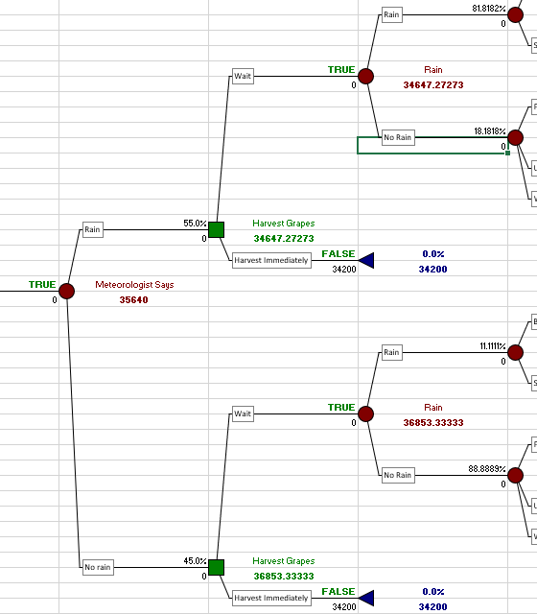

f. (10 points) Finally, what would it be worth to know for certain whether or not the storm would hit the winery before making the decision to harvest the grapes? Please show the tree below that you use to calculate this value, along with the value itself.

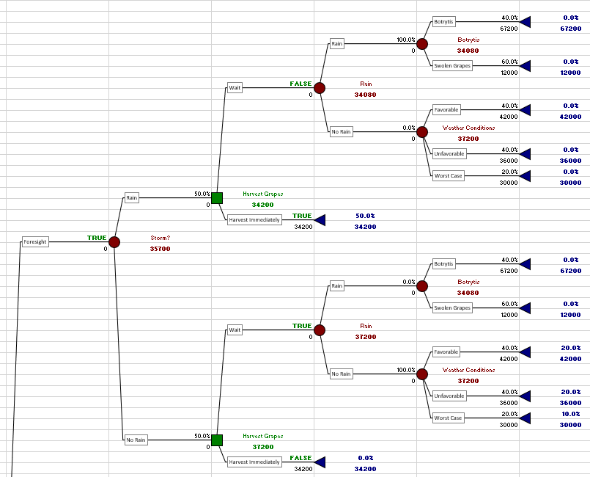*The decision tree below shows the expected values given that Mr. Jackson can know for an absolute certainty whether or not it will rain before he decides to harvest his grapes. Because the expected value of waiting if there is no rain is the highest, and because the expected value of waiting given rain is slightly lower than the expected value of harvesting immediately, then we expect that this perfect information will provide value. The expected value of the tree given this information is shown under the word “Storm?” and is $35,700. Because we know the expected value without this information was $35,640, we can conclude that this information is worth $60.*

**Problem 2 (50 points)**

Nathan Armstrong’s thinking about the Avion contract for 50 smart valves had begun to crystallize during his trip to the Blue Ridge Mountains. Upon returning to the office, however, he was dismayed to discover two new email messages relating to the contract. The first message was from Richard Hubble, the president of Gemini Software: “Urgent. Please call.” When Armstrong called, Hubble told him that a crisis had arisen that would force Gemini to delay starting the project for three months rather than starting it immediately, as previously planned. In light of the new circumstances, Hubble said that Gemini would complete the project during the subsequent five months for a fixed price of $160,000 regardless of the resources required. Armstrong recognized that this “wrinkle” would prevent Orion from benefiting from any savings associated with the shortcut—assuming it would work—but was pleased that he no longer bore the risk of the shortcut not working.

The second message was from Alicia Harrington, head of Orion’s Engineering Division, who had several things to discuss. First, she indicated that she had just received word that a major project had been postponed, which would change the timing of Armstrong’s supersmart-valve project. Armstrong’s project would have to begin immediately. As a result of the postponement, Harrington asserted that sufficient internal resources could be devoted to the project so that she could now guarantee a successful valve redesign over the next three months with the same incremental cost of $80,000 for the engineering services.

Harrington also said that she had been discussing the project with her Engineering colleagues, who had raised the issue of precisely what was meant by “modest” and “dramatic” improvement. A new, not yet widely adopted performance measure for evaluating valve-system performance was called the Sager scale: a complex function of the control system’s reaction time and the derivative and integral action of the valve. The existing old valve SV44A-10 was rated at 522 on the Sager scale, which had a range of 200 to 800. Harrington proposed that the Sager scale be specified in the contract to measure performance, and she suggested that any improvement rating above 600 be considered “dramatic”.

Armstrong took the opportunity to bring up the fact that the rescheduling of the engineering project meant that Gemini would not be able to begin the software development until after the valve redesign was completed, and asked Harrington if that would be a problem. She responded that it merely meant they would not know the true performance of the valve until the software was completed. Nevertheless, she said she would be able to estimate the Sager value of the new valve based on the software specifications (i.e., without the software itself) once the prototype valve emerged from the engineering project. Currently, she believed that this “estimated Sager” would be anywhere between 525 and 700, and she thought that a rating around 625 was most likely. She also indicated that the “actual Sager,” which would be known only after the software was completed, would be normally distributed around her “estimated Sager” value, with a standard deviation of 20 points.

To pin down the precise terms of the performance incentives for the new valve system, Armstrong called Andre Gide, who was familiar with the Sager scale and agreed to its use. After a lengthy conversation, the two men agreed that, for every Sager point above 522 and up to 600, the price of each valve system would increase by $25 a point over the $10,000 price of the old valve. If the improvement rating exceeded 600 (i.e., was considered a dramatic improvement)—in addition to the extra $1,950 for the first 78 points of improvement—Armstrong proposed $200 a point for each point above 600. Gide, after some reflection, agreed to this arrangement, with the proviso that the total price per valve could not exceed $25,000, which was somewhat better than the 100 percent premium he had originally offered. Armstrong also recalled that it costs $8000 per valve to manufacture the old valve, and that it would cost $10,500 to manufacture the new valve.

1. (20 points) Assume that you will develop and sell the new valve to Avion no matter what “estimated Sager” Harrington provides. Develop a simple @Risk model to estimate the profit associated with this strategy, and paste the model below (show the formulas). *As a hint, the model can be created with five rows, one each for an estimate of performance, for the actual performance, for the increased contribution to profit per unit, for the total contribution to profit per unit and for the total contribution to profit. But, there are other ways to create the logic of the model so do not feel constrained by that suggestion.*

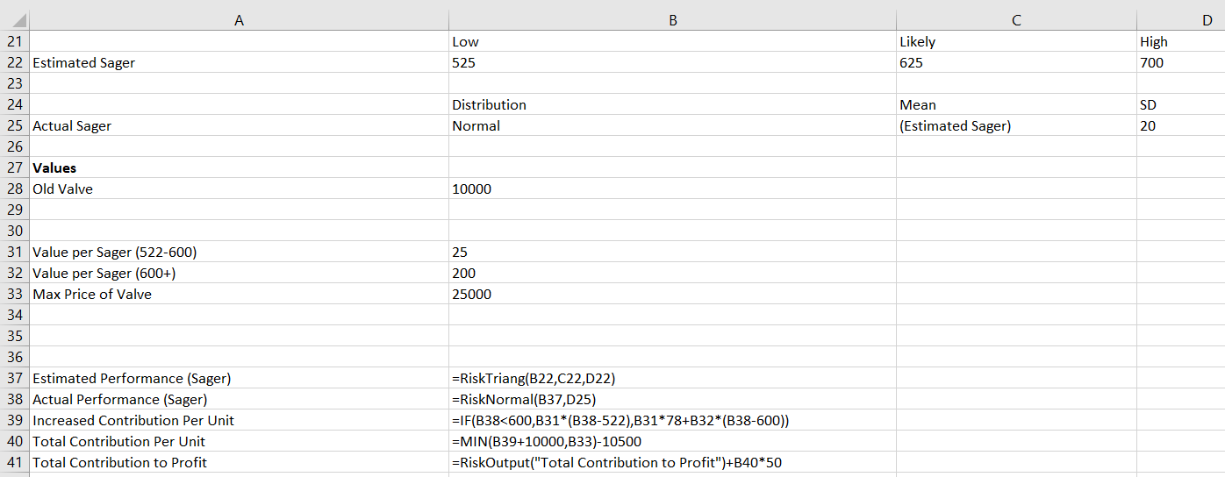

1. (5 points) Report the expected value and the standard deviation associated with the development of this new valve. What is the probability that the total contribution to profit for selling 50 of these valves will be more than $100,000? Would you recommend producing the new valve or producing the old valve for a guaranteed contribution to profit of $100,000?

*The mean and standard deviation associated with the output from the formulas above (which sum over the 50 total valves as indicated in B41) are $61,505, and $257,358, respectively. The probability that selling 50 of these valves generates more than $100,000 is 41.4%. Thus, because the expected value of contribution to profit for this project is less than $100,000 net of engineering and software development costs, then I would recommend that Orion produce the old valves.*

1. (15 points) Suppose you consider a new strategy of developing a “cut off” value. The idea is that if Harrington’s “estimated Sager” is less than this “cut off”, you abandon the new valve and just pay the $80,000 in engineering costs but save the $160,000 in software costs, and you then manufacture the old valve. Modify your simulation model above to incorporate this idea and paste this revised model below, showing the formulas.

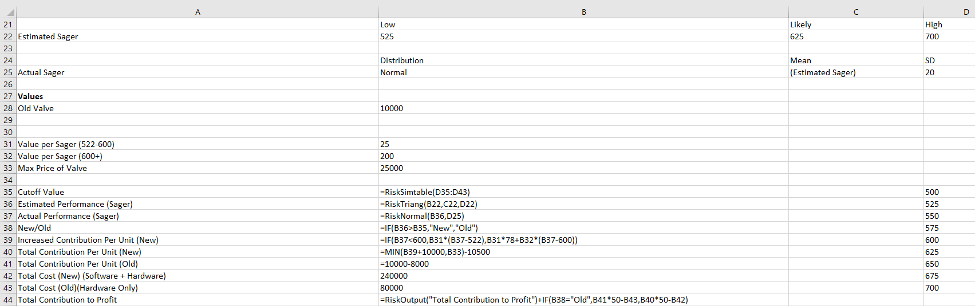

1. (5 points) Report the expected value and the standard deviation associated with the development of this new valve using this strategy. What “cut off” value for the Sager score would you recommend (approximately)?

*The mean and standard deviation of the new valve using this strategy are $133,346 and $185,400, respectively. The approximate cut-off value I obtained using RiskSimTable was 625, represented in simulation #6 shown below.*

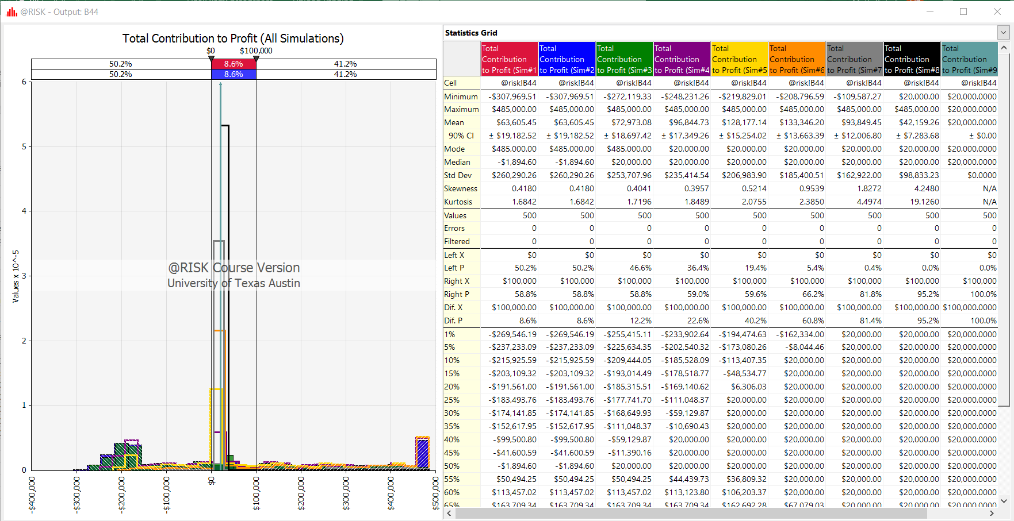

1. (5 points) Using this “cut off”, what is the probability of making more than $100,000 with this strategy? Would you recommend starting the development of the new valve using this strategy, or simply producing the old valve for a guaranteed contribution to profit of $100,000?

Using this cut off, the probability of making more than $100,000 with this strategy is still only 34.6%. As such, I don’t recommend that Orion produce the new valves, even with the cut off value. As you can see from the risksimtable above, there are no cutoff values where the median of the distribution lies above $100,000.

